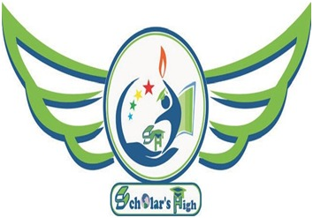
SCHOLAR’S HIGH
STD- 1 to 8
AT + PO: MARAR,RANCHI ROAD,
RAMGARH CANTT, JHARKHAND. PH: 7781033204, 8809612609

DATE:- 20/04/2021 | SUBJECT:- save the world/earth/ Save Water/Stop Pollution | NOTICE NO :- SH/CIR/EPR/21-22/05
Dear parents
Class 5-8

We are very happy to announce a task on 22nd April Earth day.

Date 22-4-21
✅ The children will need to make a poster ana a slogan on the topic " Save the Earth/World/Stop Pollution/Save Water " And make a video showing the poster and narrating the slogan .
✅You can send the video and may share the photograph only of the completed poster with the child with the slogans in the frame to this number 📲_______________.

🗓 21-04-21 ( Wednesday) will be holiday on the eve of Ramnavami.

REGARDS
SCHOLAR’S HIGH

OFFICE CONTACT NO :- 7781033204, 8809612609, 8340281624

SCHOLAR’S HIGH
STD- 1 to 8
AT + PO: MARAR,RANCHI ROAD,
RAMGARH CANTT, JHARKHAND. PH: 7781033204, 8809612609

DATE:- 20/04/2021 | SUBJECT:- save the world/earth/ Save Water/Stop Pollution | NOTICE NO :- SH/CIR/EPR/21-22/05
Dear parents
Class 1-4

We are very happy to announce a task on 22nd April Earth day.

Date 22-4-21
✅ The children will need to make a drawing on the topic " Save the Earth/World/Stop Pollution/Save Water " And make a video showing the poster and narrating the slogan .
✅You can send the video and may share the photograph only of the completed poster with the child with the slogans in the frame to this number 📲_______________.

🗓 21-04-21 ( Wednesday) will be holiday on the eve of Ramnavami

REGARDS
SCHOLAR’S HIGH

OFFICE CONTACT NO :- 7781033204, 8809612609, 8340281624

