DETAILS OF THE PARTICIPANTS

Participant number :_______of ________

Name of the Participant:___________________________________ _______________________________________________________Gender: Boy / Girls Category: Under14 / Under17 / Under19
Event : Team / Individual (Artistic) / Individual (Rhythmic)
Class :__________ Admission number :_____________________
Date of Birth :__________________ (must be same as Aadhar & School ID)
Board Registration number (for class X & XII) :______________________________________
Name & Address of the School :____________________________________________________
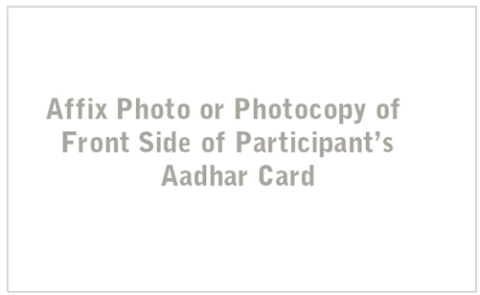
______________________________________________________________________________Affiliation number of the school :____________________________________________________
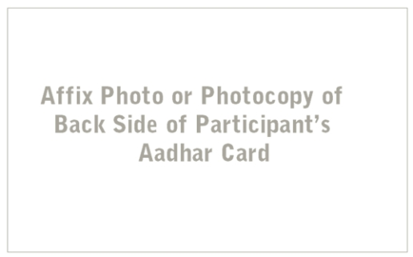

Alternate Contact Number in case of emergency:
______________________________________________
Kindly mention if the Participant has any health conditions or allergies:_____________________________________
______________________________________________
______________________________________________
______________________________________________

(Signature and Stamp of Principal)

